**How to install and run the code**

We ran this code in google colab.

First, open a new notebook in google colab.

Upload to the drive the project folder containing the dataset and the folders to which voice clips and lip animations will be added. (LipNet folder)

After that, upload the project notebook by clicking on File->upload notebook

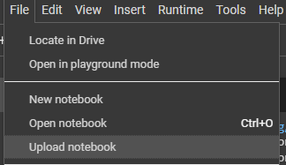

The following installations must be performed:

!pip install tensorflow==2.10

**This installation must be done before running the program**

Click on “RESTAT RUNTIME”

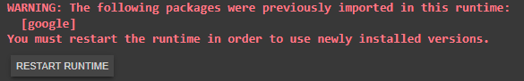

After initializing the runtime, click on “Run all”

After that, you must create a connection to the drive in order to add the data set on which the training was performed:

from google.colab import drive

drive.mount('/content/gdrive')

**Download the dataset:**

#download dataset from url link and extratced it to drive

url = 'https://drive.google.com/uc?id=1YlvpDLix3S-U8fd-gqRwPcWXAXm8JwjL'

output = 'data.zip'

gdown.download(url, output, quiet=False)

gdown.extractall('data.zip')

**Loading the trained model:**

model.load_weights('/content/gdrive/MyDrive/LipNet/models/checkpoint')

At the end of the program execution, a random video will be selected to demonstrate the program execution.

**Loading video for prediction:**

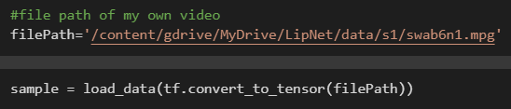After all these steps it is possible to predict what is said from any video we want, by combining the second algorithm we will also get a voice output.

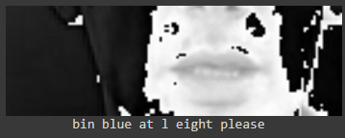The final output of the program will look like this:

